|  |  |
| --- | --- |
| **Ex No:9** | **YACC** |
| **Date of Exercise** | **11th March, 2019** |

**AIM**

|  |
| --- |
| Write a YACC program to perform basic arithmetic operations using the following grammar.  **DESCRIPTION** |
| Yacc is a computer program for the Unix operating system. It is a LALR parser generator, generating a parser, the part of a compiler that tries to make syntactic sense of the source code, specifically a LALR parser, based on an analytic grammar written in a notation similar to BNF. |

**SOURCE CODE**

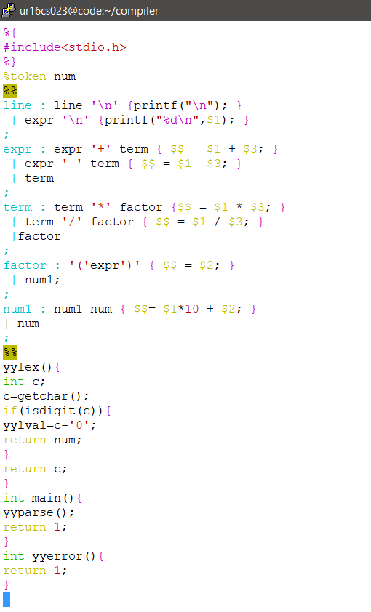

**Output**

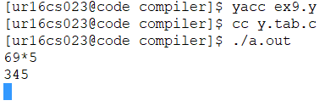

**Video Link**

**https://youtu.be/7SLcL2O3g8A**

**Result**

Hence YACC program to perform basic arithmetic operations is successful executed.